11.4 Volume GP 3 All images captured at 110%

Large ball pit

Small ball pit

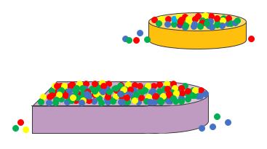

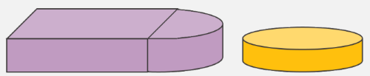

RADIUS



HEIGHT

DIAMETER

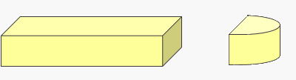

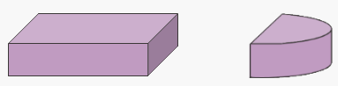

RADIUS

LENGTH

WIDTH

HEIGHT

HEIGHT

24 feet

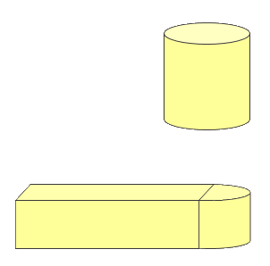

SMALL BALL PIT

8 feet

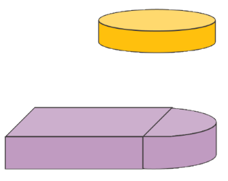

LARGE BALL PIT

10 feet

3 feet

5 feet

12 feet

2 feet

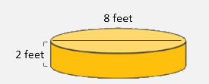

SMALL BALL PIT

Snipped from the white background and switched background in paint.net

LARGE BALL PIT

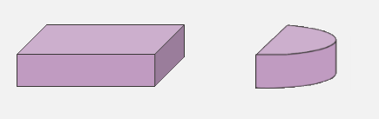

10 feet

3 feet

3 feet

12 feet

5 feet

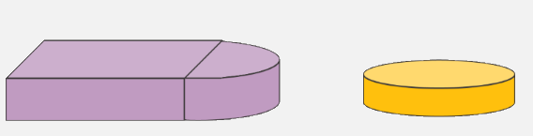

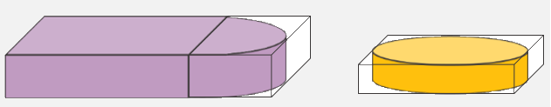

3 feet

2 feet

8 feet

8 feet

10 feet

5 feet

12 feet

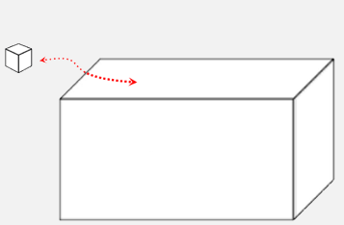

How many cases in 578 cubic feet?

1 case = 6.1 cubic feet